|  |  |  |  |
| --- | --- | --- | --- |
| Name:  Class: | ____________________________________  ________________ | | Date: ___________ |
|  | **Year 11 Essential Mathematics Unit 2**  SCORE:  / 18    **Mini Test 2.4 2018**  **Topic – Ratios**  ***Full working out MUST be shown to get full marks for each question.*** | | |
| **Total Time:** | 30 minutes |  | |
| **Weighting:** | 1% |
| **Equipment:** | To be provided by the student: Pen, pencil, ruler, scientific calculator,1 single sided page of A4 notes | | |

**Question 1**

Complete the table below (6 marks)

|  |  |  |
| --- | --- | --- |
| **Ratio** | **Percentage** | **Fraction** |
| **1:4** | **% to %** | **_____ to ______** |
| **:** | **12 % to 88 %** | **_____ to ______** |
| **:** | **% to %** | $\frac{3}{20}$**to $\frac{17}{20}$** |

**Question 2**

A pancake recipe that you need 2 cups of milk to 1 cup of flour. (1, 1, 1 Marks)

1. Write this as a ratio of milk to flour.

The recipe says it makes 20 pancakes. What would the ratio look like if we need;

1. 40 Pancakes
2. 10 pancakes.

**Question 3**

Mike, Michelle and Martin have all gone into business together. Mike has invested $10,000, Michelle has invested $15,000 and Martin has invested $25,000. (2, 2 Marks)

1. Write this as a ratio and then simplify it
2. The company has made $150,000 profit in its first year. Using the ratio above, work out how much profit each person should receive.

**Question 4**

Marcus has a map of the school. He is using the map to work out how far it is between his English class and his Music class. On the map he measures it as 12 cm. The map has a scale of 1:1000. How far has he travelled? (1, 1 Marks)

1. In centimetres
2. In metres

**Question 5**

Steve, Jenny and Lucy order 3 pizzas. Each pizza is cut into 8 pieces. They each eat the pizzas in the ratio of 4:3:5 (Jenny to Lucy to Steve). (1, 2 marks)

1. Mark on the pizzas below how much Jenny ate, how much Lucy ate and how much Steve eats.

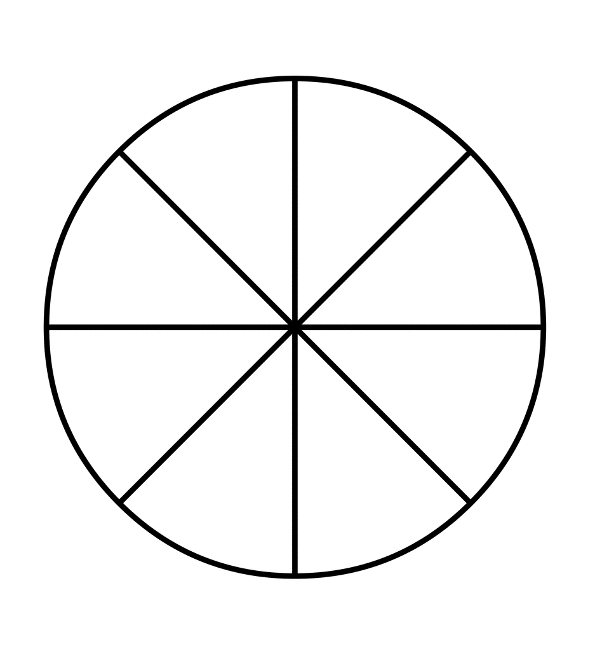

1. If the Pizzas cost $36 in total, how much does each person owe to keep the cost fair?

**End of Test**